# RESULTS:

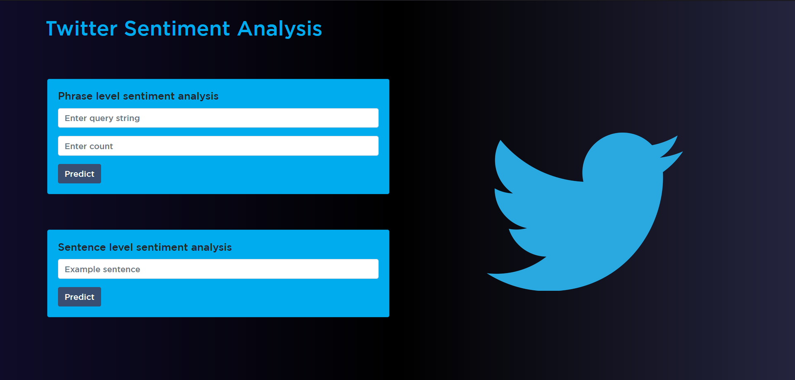

FIG 1: HOME PAGE OF THE WEB APPLICATION.

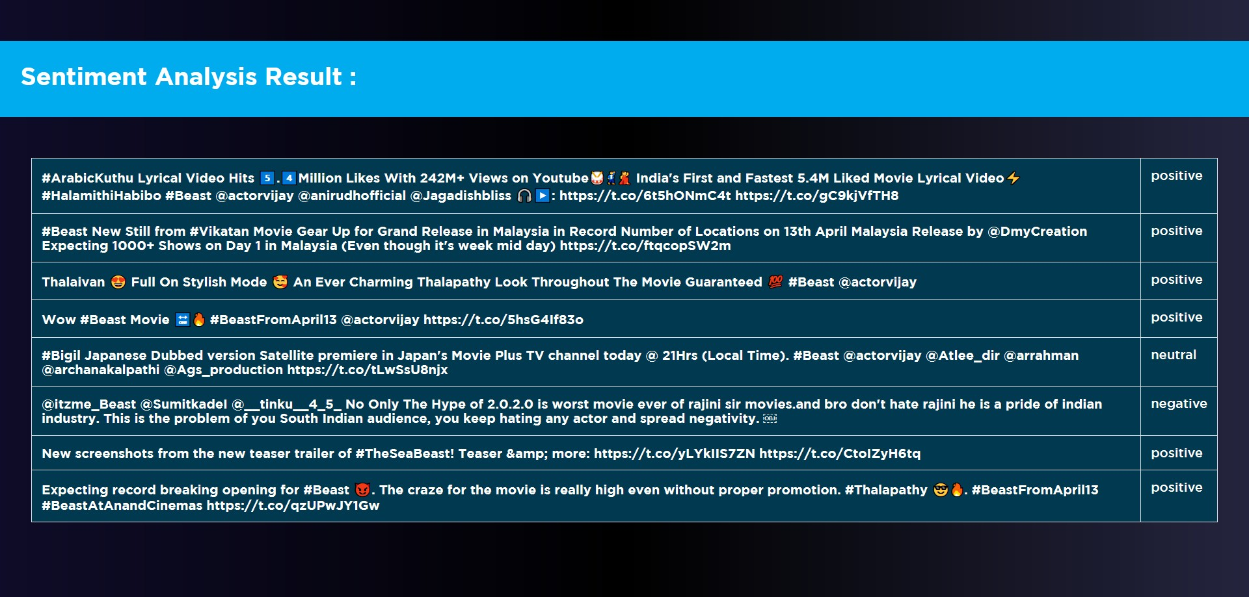

FIG 2: OUTPUT FOR THE QUERY “BEAST” & COUNT “8” IN TWITTER PREDICTION SECTION.